CHAPTER 6
WORK AND KINETIC ENERGY
Discussion Questions
Q6.1 No. Whether work is positive or negative does not depend on any choice of coordinates. Work done on an object by a force for a specified displacement of the object is positive if the force has a component in the direction of the displacement. The work is negative if the force has a component opposite to the direction of the displacement of the object.

Q6.2 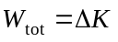. At constant speed means 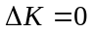 and 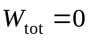. If friction can be neglected, for any upward displacement of the elevator the positive work done by the tension in the cables equals in magnitude the negative work done by gravity.

Q6.3 You must specify the object on which the work is done. 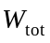 in the work-energy theorem is the total work done on the object whose kinetic energy is 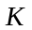. The two forces in a Newton’s 3rd law pair do work on different objects.

Q6.4 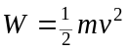 since the object starts from rest. Let 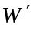 and be the work and speed when twice the work is done, so 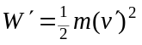. 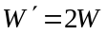, so 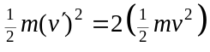. This gives 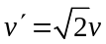. The speed increases by a factor of 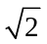 when twice the work is done.

Q6.5 Yes. If the net force is always perpendicular to the displacement of the object then the net force doesn’t do any work. An example is a block moving in a horizontal circle on the end of a string. If the block moves on a horizontal, frictionless surface, then the net force on the block is the tension in the string. This force is radial and there is no displacement in this direction and the tension does no work on the block. The net force changes the direction of the velocity but doesn’t change the speed and the kinetic energy of the object is constant, as the work-energy theorem says it should be when no net work is done.

Q6.6 The tension has the same magnitude at both ends of the rope. The tension does positive work on the cart and negative work on the bucket. The displacements of the cart and bucket have the same magnitude, so the work done on each by the tension has the same magnitude and the total work done by the tension is zero.

Q6.7 There is no work done on the bob. The speed of the bob is constant so its kinetic energy is constant. By the work-energy theorem the total work done on the bob is zero. The tension F is directed along the wire. The bob has no displacement in this direction so this force does no work. The weight mg of the bob is vertically downward. The bob has no displacement in this direction so the gravity force does no work.

Q6.8 In each case the only force that does work on the object is gravity. The work done by gravity is given by 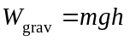 and this is the same in all three cases. Since the object is released from rest, 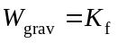, where 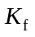is the kinetic energy the object has at the bottom. (i) In (c) the object has greater mass and hence less speed for the same kinetic energy. Therefore, cases (a) and (b) have the same speed at the bottom and greater speed than case (c). (ii) For all three cases the same amount of work is done.
Q6.9 The force must do both positive and negative work, because for some of the displacement the force is in the -direction and for some of the displacement the force is in the -direction. The net work done by 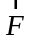 is zero if the positive and negative works have the same magnitude. A possible graph of F versus x is sketched in Fig. DQ6.9.

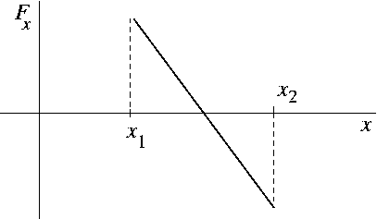

Figure DQ6.9

Q6.10 The change in speed is 5 m/s in both cases, but the kinetic energy depends on 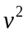and the change in is larger for the 15 to 20 m/s speed change.

Q6.11 The direction of the velocity is different for each object; they do not have the same velocity. The speed (the magnitude of the velocity) is the same for all three objects. The kinetic energy depends on the magnitude of the velocity, not on its direction, and the three objects all have the same kinetic energy.

Q6.12 Yes, the total work can be negative. For example, the net force could be opposite to the displacement throughout the motion. An example is the motion of a ball thrown upward. In the absence of air resistance the net force is gravity and is downward. For the motion from just after it leaves the thrower’s hand to its maximum height the displacement is upward and the net work done on the ball is negative. No, the negative total work cannot have a magnitude larger than the initial kinetic energy of the object. The work-energy theorem says that 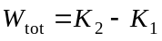. 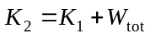. If the total work is negative and if its magnitude were larger than 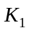,then this equation would say 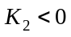 and this is not possible. For example, consider a net force in a direction opposite to the initial velocity of the object. The force does negative work until it has removed all the kinetic energy of the object and the object is momentarily at rest. After that the object starts moving in the direction of the force and the force starts doing positive work.

Q6.13 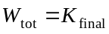 since 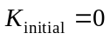. Thus, 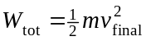. 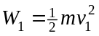 and 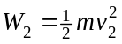. If 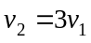, then 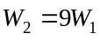. To produce three times the final speed must do nine times the work.

Q6.14 No. In the frame of the driver the truck is already at rest and no work is needed.
Q6.15 (a) There is no vertical displacement of the briefcase so the vertical component of the force your hand exerts does no work. The kinetic energy of the briefcase doesn’t change, so in the absence of air resistance there is no horizontal component of the force your hand exerts, and this force does no work. In the presence of air resistance, the force your hand exerts does a small amount of positive work, equal in magnitude to the negative work done by the air resistance force. (b) There is an upward displacement of the briefcase so the upward force your hand exerts does positive work on the briefcase. The positive work done by your hand equals in magnitude the negative work done by gravity, if the initial and final speeds of the briefcase are the same.

Q6.16 Yes, if the displacement of the object is in the direction of the friction force. For a box in the back of an accelerating truck the friction force on the box is the net force that causes the box to accelerate along with the truck (if the box doesn’t touch the sides of the truck and if it doesn’t slip). The positive work done by friction equals the increase in kinetic energy of the box.

Q6.17 The work you do is 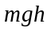, where is your mass and is the vertical height you travel. Your average power is 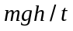,where is the time it takes you to run up the stairs. 1 hp = 746 W.

Q6.18 (a) “Strong” indicates the force the person can apply. Power is the rate of doing work. A small force can result in large power if the force is applied to an object that is moving at large speed. (b) The worker must apply a large upward force on the bag equal to the weight of the bag. But this force does no work because the displacement of the bag is horizontal and has no component in the direction of the force.

Q6.19 No. 28,000 hp = (28,000 hp)(746 W/1 hp) = 20.9 MW. The power output (30 MW) would exceed the power input (20.9 MW), and this violates conservation of energy.
Q6.20 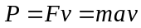, if the motion is horizontal and if air resistance can be neglected so that the force 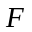 supplied by the engine is the net force. As increases, decreases; the acceleration is greater at the beginning.
Q6.21 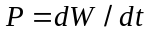, so 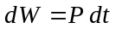 and the area under the versus curve is the work done between and . 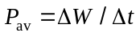, so 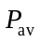 is the area divided by 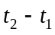. The graph is given in Fig. DQ6.21 and the calculation is as follows: area = 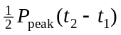. = area/(). = 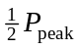.

- 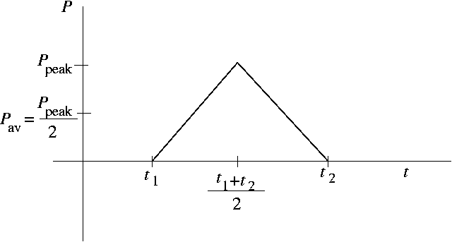

- Figure DQ6.21

Q6.22 (a) Yes. If the net force does zero work during a displacement then the particle’s speed remains constant. An example is for a particle moving in a circle at constant speed. The net force is radially inward and does no work. (b) No. By 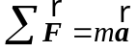, the net force produces an acceleration and this changes the velocity of the particle. (c) Yes. As reasoned in (a) the speed can remain constant. The kinetic energy depends on the speed of the particle and is independent of the direction of the velocity, so the kinetic energy can remain constant.

Q6.23 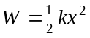 and 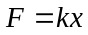, so 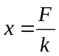 and 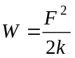. If F is doubled then the spring stretches a distance 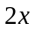and the work done is 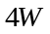.

Q6.24 Let 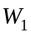 be the work required to stretch the spring a distance x and let 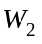 be the work required to stretch the spring a distance from its unstretched length. Then 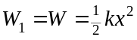 and 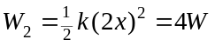. The additional work to stretch the spring an additional distance x is 

